# Hands-on Experiment # 4 : Worksheet

Section______________ Date__________________________________

No more than 3 students per one submission of this worksheet.

Student ID _________________________________ Name______________________________________

Student ID _________________________________ Name______________________________________

Student ID _________________________________ Name______________________________________

## Part A: Java API

1. Place the file “Point.class” (which is a Java bytecode) in the same folder as the Java source code files you will be writing in this Hands-on Experiment.
2. Understand the source file “Point.pdf” (Point.java). Assume we want to create a point called “startPoint” at (2,3). Write the code to do the following task:
   1. Create this point
   2. Compute the distance of this point to the original point (origin)
   3. Clear this point

public class PartA {

public static void main(String[] *args*) {

Point p = new Point(2, 3);

double dist = p.distance(Point.origin);

System.out.println(dist);

p.clear();

}

}

1. Explain the difference between “static data” and “object data”

Static data belongs to the class while object data belongs to the specific instance/object of the class

## Part B: Scanner

1. Write a Java program “PointTest1.java” to read two points from user. Locations x and y are entered by user separately. The output is the distance between two points. (Hint: use “Scanner” to input data from user)
   1. List your source code below.

import java.util.Scanner;

public class PointTest1 {

public static void main(String[] *args*) {

Scanner sc = new Scanner(System.in);

int x1 = sc.nextInt();

int y1 = sc.nextInt();

int x2 = sc.nextInt();

int y2 = sc.nextInt();

Point a = new Point(x1, y1);

Point b = new Point(x2, y2);

double dist = a.distance(b);

System.out.println(dist);

}

}

* 1. Capture the program output.

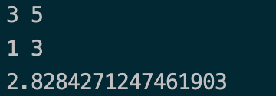

## Part C: BufferedReader (Advanced Problem)

1. Place the file “location.txt” in the same folder as the Java source code. In this file there is a single point, where x and y are shown in Line 1 and 2, respectively. Write a Java program “PointTest2.java” to read “location.txt” and output the distance to the original location (origin). (Hint: use “BufferedReader” to read data from file)
   1. What is the location in the text file “location.txt”?

X=20, Y=50

* 1. List your source code below.

import java.io.IOException;

import java.io.BufferedReader;

import java.io.FileReader;

public class PointTest2 {

public static void main(String[] *args*) throws IOException {

BufferedReader in = new BufferedReader(new FileReader("location.txt"));

String p1 = in.readLine();

int x = Integer.parseInt(p1);

String p2 = in.readLine();

int y = Integer.parseInt(p2);

Point p = new Point(x, y);

System.out.print("X = " + x + " Y = " + y + '\n');

double dist = p.distance(Point.origin);

System.out.println(dist);

}

}

* 1. Capture the program output.

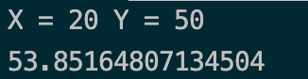

* 1. Modify location in the text file to “(2, 3)”. Then, rerun your program and capture the program output.

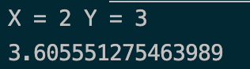

Submit this worksheet (by only one member of the group) via <http://www.myCourseVille.com> (Assignments > Hands-on Experiment # 4) **before noon of the day after your lecture.**